NUMBER LINE
KS1 – 2003 Paper 2
1.
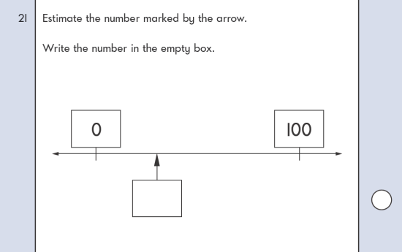
KS1 – 2004 Paper 1
1.

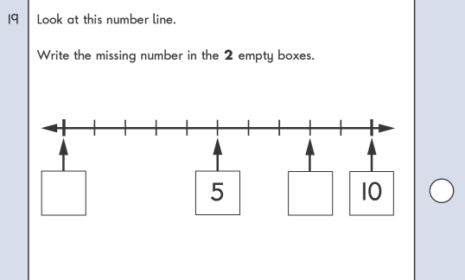
KS1 – 2004 Paper 2
2.

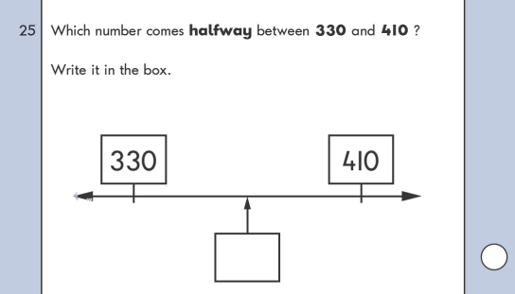
KS1 – 2005 Paper 1
3.
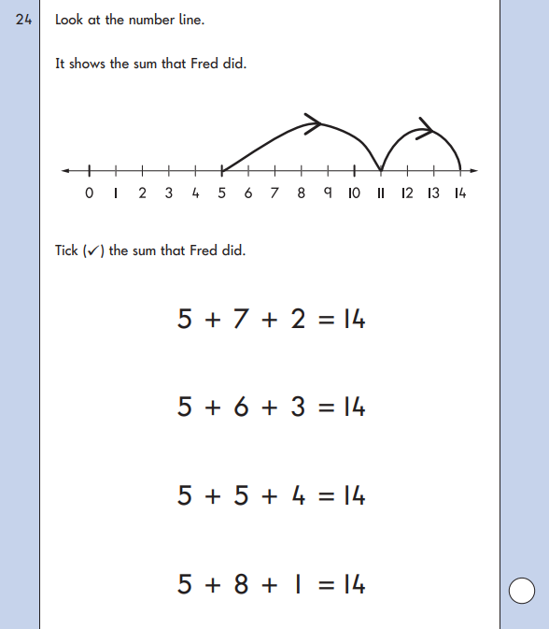
KS1 – 2005 Paper 2
4.
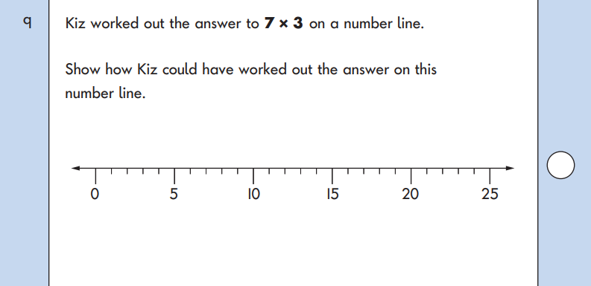
KS1 – 2007 Paper 1
5.

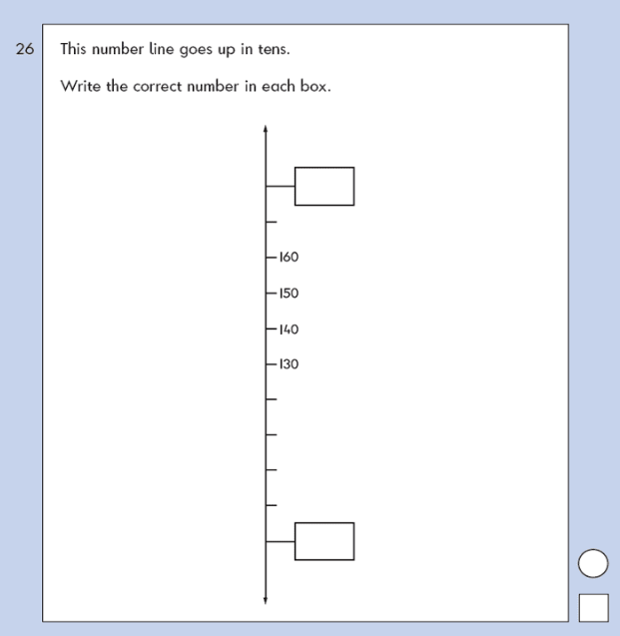
KS1 – 2007 Paper 2
6.

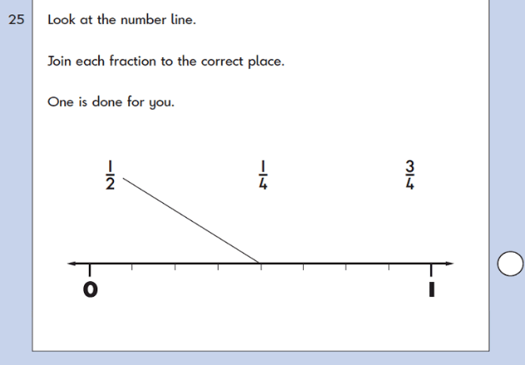
KS1 – 2016 Paper - Reasoning
7.
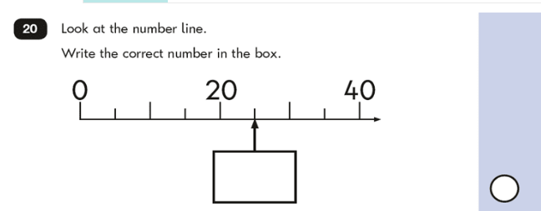
KS1 – 2016 Paper – Reasoning (Second)
8.

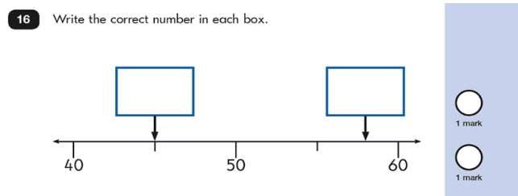
KS1 – 2017 Paper – Reasoning
9.
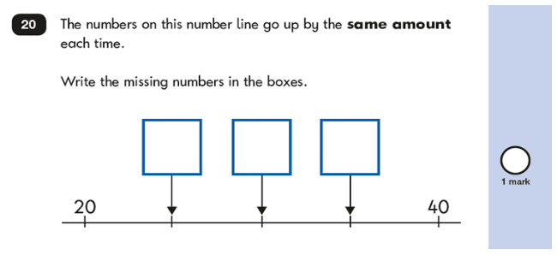
KS1 – 2018 Paper – Reasoning
10.
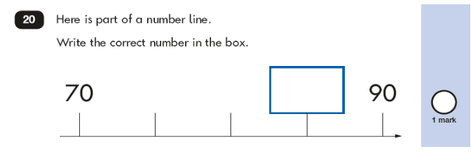
KS1 – 2019 Paper – Reasoning
11.
